
GURU NANAK INSTITUTIONS TECHNICAL CAMPUS (AUTONOMOUS)
SCHOOL OF ENGINEERING AND TECHNOLOGY

Department of Computer Science and Engineering

Academic year (2024-2025)

PROJECT BASED LEARNING

Max Marks - 10
_____________________________________________________________________________________________
Name of the Lab & Code: 22PC0CS17
Year/ Sem :3rd/1st
Section: CSE-2
Roll Number: 23WJ1A0575
Name of the Student: G.Sharavani
Topic Name: storing form data in file

Introduction:
Storing form data in a file is one of the simplest methods to persist user inputs. In web applications, HTML forms are used to collect information such as name, email, or feedback from users. This data can be processed by a backend script and then written into a file for record-keeping. In DevOps, such practices are useful for testing CI/CD workflows, verifying automation, and managing application logs or user inputs. This experiment helps us understand how data moves from the frontend (form) to the backend (server) and finally into a storage file.

Experiment no's to be used for implemented :

- Write code for simple registration form

Given Input:
- The user will give the input like their details in the form of name, email or any message

Expected output:
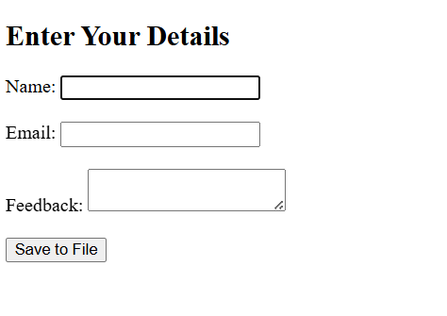

Student Signature Faculty Signature

